**Commerce Bank Web App**

**Test Report**

**Team AAFK**

December 4, 2022

Team Members

Andrew Floyd

Kevin Floyd

Forrest Spencer

Andres Garcia

Introduction

This document outlines the outcome of completed system tests.

Unit Tests

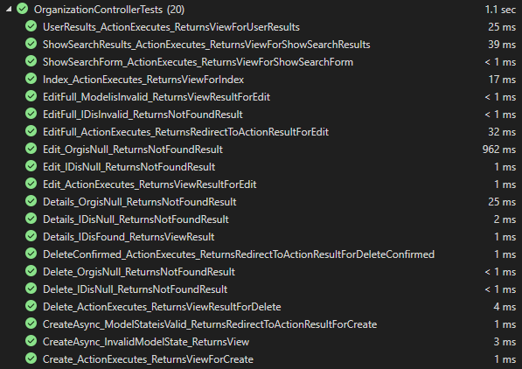

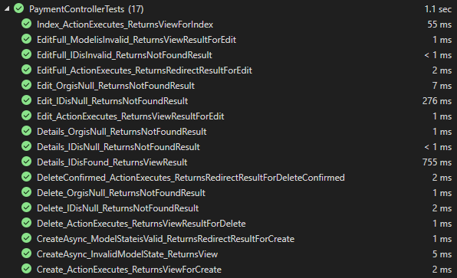

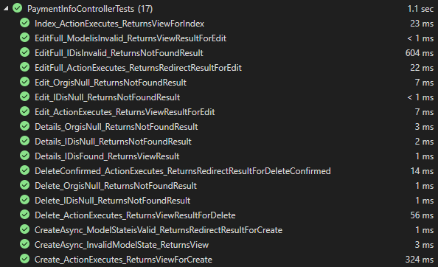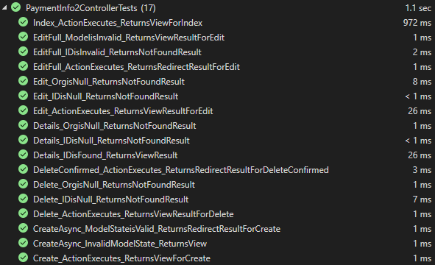

Our tests all passed, ensuring that the controllers were performing properly and returning the correct values.

Summary

The testing procedure to date has been conducted using unit testing with Moq. Features tested include but are not limited to:

· Indexing of Fundraisers, Payments, and Payment Info

Test Case: 1.1, 2.1, 3.1

· Creation of Fundraisers, Payments, and Payment Info

Test Case: 1.2, 2.2, 3.2

· Viewing details of Fundraisers, Payments, and Payment Info

Test Case: 1.3, 2.3, 3.3

· Editing of Fundraisers, Payments, and Payment Info

Test Case: 1.4, 2.4, 3.4

· Deleting of Fundraisers, Payments, and Payment Info

Test Case: 1.5, 2.5, 3.5

More unit testing will be done as more functionality is added to the site. This could include things like 2FA, account management, etc.